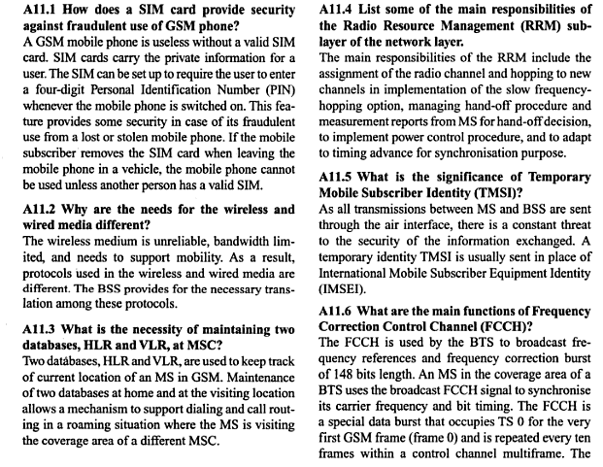

Q 1: What is the difference between CDMA and GSM?
ANS: he important differences are:
Data Transfer Speed:
- CDMA is faster than GSM.
- CDMA2000 downstream rate is 2 megabits / second, through EVDO, where GSM downstream rate is up to 384 kilobits / second, through EDGE technology
Subscriber Identity Module (SIM) cards:
- SIM is tied to the network, rather than the actual phone. Phones with card-enabled can be used with any carrier of GSM
- Proprietary handsets are linked to one carrier only and not card-enabled in CDMA
Roaming:
- GSM carriers have wider coverage of more rural areas, where as CDMA may not cover rural areas compared to GSM carriers
International Roaming:
- GSM has facility to offer more international roaming, as the number of connections in world market dominate GSM network.
- CDMA phones do not have the capacity; however, there are more countries that use CDMA networks.

Q 2: What is the importance of CDMA in today’s cellular world?

ANS:
- The transition to digital radio through the process of defining standards is implementing about 90% in the cellular industry.
- Smooth transition to digital standards is involved in CDMA technology.
- Most often, it can be viewed as improved and replacement technology of TDMA
- Moving towards 4G technology is compatible with CDMA technology.

Q 3: What is the difference between CDMA and GPRS? Which of them is better? Why?

ANS:
The Differences:
- CDMA is one of the types of mobile connections for making calls where as GPRS is a technology for internet connections through a mobile phone.
- GPRS enables to surf the internet from a mobile phone. GPRS technology is used in other gadgets apart from mobile phones.
- W-CDMA technology is faster than GPRS, since the user cares about the technology that is applied for air interface.
- Average latency on GPRS is around 1.3 seconds, whereas on CDMA is around 400 milli second
- GPRS supports only User Datagram Protocol, whereas CDMA supports both UDP and TCP
- GPRS relies on Network Address Translation and a private IP address is assigned to it. On the other hand CDMA assigns a public IP address CDMA is better because:
- E-mail is pretty light, until you enter MS-Office.
- Pocket PC’s support for office documents with similar functionality which can be had on Palm OS and Symbian
- Upon availability of APIs, a software developer could write various applications, like voice transfer, data transfer to client’s account, integrating billing amount etc.
- Web services could be utilized.

Q 4: Explain the following two types of hand off in CDMA system: a.) Soft handoff b.) Softer handoff?

ANS:
a.) Soft handoff
- Soft handoff is a feature in which a cellular phone is simultaneously connected to two or more cellular phones during a single call
- It is he overlapping of repeater coverage ones, which enables every cell phone set is always well within the range of a specific repeater.
- More than one repeater can send and receive signals to transmit signals to and from mobiles.
- All repeaters are used with the same frequency channel for each mobile phone set.
- Practically no dead zones and as result, the connections seldom interrupted or dropped.
b.) Softer handoff
- Softer handover is a significant soft handover in which the added and removed links belong to the same node
- Macro diversity with maximum ratio combining could be performed in the same node
- The movement of handoff, when a user can be served in another cell more efficiently (less power emission, less interference), is the most obvious cause for better performance.

Q 5: Explain following forward link channels in CDMA system: a.) Pilot Channel b.) Sync. Channel

ANS:
Pilot Channel
A forward link channel which is a base to mobile that modulates only by the pilot PN. It spreads common codes to all signals transmitted from a given base station.
Several critical important functions are provided by the pilot channel for forward links in IS-95 systems
The pilot channel modulation facilitates the process of time synchronized replica generation at the receiver of the PN spreading sequences. These are utilized at the transmitter for modulating the synchronization, paging and traffic channels. These are transmitted from the same base station.
Sync. Channel
A base station transmits a Sync-Channel that spreads with Walsh code 32.
The frame of synch channel is 80/3ms long with frame boundary is aligned to the pilot.
Sync channel transmits a single message continually, called Sync Channel Message.
The Sync Channel Message contains network information, including the PN offset that is used by the Base Station sector.
The length and content of the message is dependent on the P_REV.
The message transmission rate is 32 bits / frame.
The message is encoded to 128 symbols
The message yielding rate is 1200 bits / s.

Q 6 :What is the maximum data rate supported by a GSM system?

ANS:
- The maximum data rate supported by a GSM system is 9.6 kbps.
- However there are extensions to GSM standard to improve throughput.
- GPRS is one of the extended GSM service.
- The extended standards of GSM allows theoretical data rates on the order of 114 Kbit/s, but with throughput closer to 40Kbit/s in practice

Q: What is frequency re-use?

ANS:
- Frequency Reuse is one of the techniques for improving capacity and spectral efficiency
- Commercial wireless systems are based on Frequency Reuse that involves the partitioning of an RF radiation area into cell segments.
- A frequency that is far enough away from the frequency in the bordering segment is used by one segment of the cell.
- Similar frequency is used at least two cells apart from each other.
- This practice enables various cellular providers to have several customers for a given site license.

Q: What do you mean by ARFCN?

ANS:
- Absolute Radio Frequency Channel Number, a code to specify a pair of physical radio carriers and channels within the spectrum that is allocated for cellular mobile communications
- ARFCN is used for transmitting and receiving on the UM Interface, one to uplink signal and one to downlink signal
- ARFCN’s bandwidth is 270.833 kHz; channel spacing is 200 kHz in a given GSM band
- The uplink-downlink spacing is generally 45 / 50 MHz
- If Frequency Division Duplex is operated in the system, then the channel number is associated with both uplink and downlink radio channels
- ARFCN is 1-124 within GSM900 spectrum, 512-885 within GSM1800, 512-810 within GSM1900, are used.

Q: Differentiate between GSM and GPRS?

ANS:
The differences between GSM and GPRS are depicted in the following table
GSM | GPRS
Uses one among 7 slots | Uses as many as 4+1 time slots
Connecting resources to each unit from remote location to the back office is done through a direct dial up | Does not claim any resources until some data is sent. The information is divided into packets
Circuit switched mode of operations | Packet switched mode of operations
Dedicated channel all the way to the destination is provided to the customer | One or more dedicated channels are assigned by the operator specifically for shared use

Q: What multiplexing schemes are used in GSM and for what Purpose?
ANS:
Space division multiplexing (SDM): Operators design the cell layout, place
Base stations and reuse frequencies according to certain cluster patterns.

2) Frequency division multiplexing (FDM): Regulation authorities assign
Channels to operators. Operators assign channels to base stations. Base
Stations assign a certain channel to a terminal during data transmission.

3) Time division multiplexing (TDM): Base stations assign a time slot or

Several time slots to a terminal for transmission.

